# NEW ZEALAND

The [OECD Regional Outlook](https://www.oecd-ilibrary.org/urban-rural-and-regional-development/oecd-regional-outlook_2dafc8cf-en) reviews recent trends, policy developments, and prospects across OECD regions, including the underlying causes driving regional inequalities in performance and well-being. The report offers evidence, guidance and policy recommendations on how to improve competitiveness and productivity, promote inclusive growth, accelerate the net-zero transition and raise well-being standards through effective regional development policy and multi-level governance.

## Territorial definitions

The data in this note reflect different sub-national geographic levels in OECD countries. In particular, **regions** are classified on two territorial levels reflecting the administrative organisation of countries: large regions (TL2) and small regions (TL3). In Canada, TL2 corresponds to the provinces and territories.

Small regions are classified according to their access to metropolitan areas (Fadic et al. 2019). The typology classifies small (TL3) regions into metropolitan and non-metropolitan regions according to the following criteria:

* **Metropolitan regions**, if more than half of the population live in a FUA. Metropolitan regions are further classified into **metropolitan large**, if more than half of the population live in a (large) FUA of at least 1.5 million inhabitants; and **metropolitan midsize**, if more than half of the population live in a (midsize) FUA of at 250 000 to 1.5 million inhabitants.
* **Non-metropolitan regions**, if less than half of the population live in a midsize/large FUA. These regions are further classified according to their level of access to FUAs of different sizes: **near a midsize/large FUA** if more than half of the population live within a 60-minute drive from a midsize/large FUA (of more than 250 000 inhabitants) or if the TL3 region contains more than 80% of the area of a midsize/large FUA; **near a small FUA** if the region does not have access to a midsize/large FUA and at least half of its population have access to a small FUA (i.e. between 50 000 and 250 000 inhabitants) within a 60-minute drive, or contains 80% of the area of a small FUA; and **remote**, otherwise.

Disclaimer: <https://oecdcode.org/disclaimers/territories.html>

Overview

|  |  |
| --- | --- |
| Population *(specify date)* and territory | Population: 5,127,400 (as of 30 September 2022) Territory: 268,021 km² |
| Administrative structure *(unitary/federal)* | Unitary parliamentary democracy under a constitutional monarchy |
| Regional or state-level governments *(number)* | 11 regional councils |
| Intermediate-level governments *(number)* | - |
| Municipal-level governments *(number)* | 67 territorial authorities |
| Share of subnational government in total expenditure/revenues (2021) | 10.7% of total expenditure  10.8% of total revenues  [Source: [Subnational governments in OECD countries: key data, 2023 edition](https://stats.oecd.org/Index.aspx?DataSetCode=SNGF)] |
| Key regional development challenges | * Increasing disparities in wealth and opportunity, skill shortages and pockets of unemployment. * Productivity challenges, with poor resource efficiency and slow growth. * Tight labour market. * Social infrastructure, particularly housing. * Advancing technologies and climate change are affecting traditional jobs. |
| Objectives of regional policy | The Government’s objective is supporting regional economies to become more productive, resilient, inclusive, sustainable and Māori-enabling (PRISM).  The Regional Strategic Partnership Fund (RSPF) is a $200 million fund which is a strategic investment approach and coordinated regional economic development work programme that supports regions to work towards achieving their economic potential. The RSPF is the Government’s main lever for regional economic development and aims to improve the economic prospects, and through this the living standards, of New Zealanders by delivering local approaches tailored to the particular needs of individual regions. |
| Legal/institutional framework for regional policy | * Te Tiriti o Waitangi/Treaty of Waitangi * Resource Management Act 1991 (reforms currently underway) * Local Government Act 2002 * Public Service Act 2020 * New Zealand Bill of Rights Act 1990 * Human Rights Act 1993. |
| Budget allocated to regional development (i.e., amount) and fiscal equalisation mechanisms between jurisdictions (if any) | Since 2018, the Government has allocated $4.5 billion towards a range of regional economic development funds and other initiatives managed and administered by Kānoa – Regional Economic Development & Investment Unit.  There are also a range of funds and initiatives throughout Government. Budget 2022 provided funding for a number of initiatives for the 2022-2023 financial year including:   * Toitu Te Whenua Regional Housing Improvement Programme - $3.6 million * Port Sector Opportunities to Support Decarbonisation, Resilience, and Regional Development - $3.7 million * Improving rural connectivity - $15 million * Dolomite Point Redevelopment Project $2.229 million * Equitable Transitions Programme - $4.523 million * Managing the Regional Strategic Partnership Fund - $13 million * The Regional Strategic Partnership Fund Operational Costs - $6.945 million |
| National regional development policy framework | The PRISM Regional Economies Framework supports regional economies to be more productive, resilient, inclusive, sustainable and Māori – enabling. The framework was developed to help deliver local approaches tailored to regions’ particular needs and advantages. Achieving more PRISM communities is a long-term vision, which takes time and requires funding and other interventions from across government, regions, local communities and businesses.  The Regional Systems Leadership Framework allocates the role of Regional Public Service Commissioner to a senior public servant in each region. Their mandate is to coordinate and align central government, coordinate with officials to resolve issues and escalate barriers to chief executives. It aims to embed new ways of working to better align how agencies invest and deliver services. |
| Urban policy framework | The National Policy Statement on Urban Development 2020 aims to ensure that New Zealand’s towns and cities are well-functioning urban environments that meet the changing needs of our diverse communities. |
| Rural policy framework | Rural Proofing Guide for policy development and service delivery planning 2018. |
| Major regional policy tools (e.g., funds, plans, policy initiatives, institutional agreements, etc.) | Funds:   * Regional Strategic Partnership Fund * The Provincial Growth Fund * The COVID-19 Response and Recovery Fund * Infrastructure Reference Group Fund * The Strategic Tourism Assets Protection Programme * NZ Upgrade Programme: Regional Investment Opportunities * COVID-19 Worker Redeployment Initiative * He Poutama Rangatahi * The Māori Trades and Training Fund * The Sector Workforce Engagement Programme.   Plans:   * Industry Transformation Plans * Regional Workforce Plans * Regional Land Transport Plans * Regional Economic Development Partnership groups’ regional priorities.   The Government’s Economic Plan supports New Zealand to become a high-wage, low-emissions economy that provides economic security in good times and bad. There are five focus areas:   * unleashing business potential; * strengthening international connections; * increasing capabilities and opportunities; * supporting Māori and Pacific aspirations; and * strengthening our foundations. |
| Policy co-ordination tools at national level | * Regional Public Service Commissioners   Government Cabinet committees:   * Cabinet Economic Development Committee * Regional Economic Development Ministers group * Māori Economic Development Ministers group |
| Multi-level governance mechanisms between national and subnational levels (e.g., institutional agreements, Committees, etc.) | * Urban Growth Agenda * Waka Kotahi National Land Transport Programme 2021-2024 * National Bill Environment Act |
| Policy co-ordination tools at regional level | * Regional Economic Development Senior Officials Group * Regional Economic Development Partnership Groups * Regional Skills Leadership Groups |
| Evaluation and monitoring tools | Impact Management Framework: Measures the impact of the Regional Strategic Partnership Fund.  Evaluation of the Provincial Growth Fund.  Cabinet’s Impact Analysis Requirements support and inform the government’s decisions on regulatory proposals. They are both a process and an analytical framework that encourages a systematic and evidence-informed approach to policy development. The requirements incorporate the Government Expectations for Good Regulatory Practice. In particular, the requirements focus on the expectation that agencies provide robust analysis and advice to Ministers before decisions are taken on regulatory change.  Cabinet papers to be considered by government have a section titled ‘*Population Implications’.* The section should be used to summarise the impacts that proposals are likely to have on population groups, as appropriate to the issue, and any actions that will be taken to address negative impacts.  Cabinet papers should also have a statement on whether the proposal is in any way inconsistent with the New Zealand Bill of Rights Act 1990 and the Human Rights Act 1993. |
| Future orientations of regional policy | The Government aims to continue to build more productive, resilient, inclusive, sustainable and Māori-enabling (PRISM) regional economies by delivering local approaches tailored to a region's particular needs and advantages. |

## Regional Inequality Trends

New Zealand experienced a decline in the Theil index of GDP per capita over 2000-2020. Inequality reached its maximum in 2008. The figures are normalized, with values in the year 2000 set to 1.

The Top 20%/Mean ratio was 0.072 lower in 2020 compared to 2000, indicating decreased polarisation. The Bottom 20%/Mean ratio was 0.04 higher in the same period, indicating bottom convergence.

**Figure 1. Trends in GDP per capita inequality indicators, TL3 OECD regions**

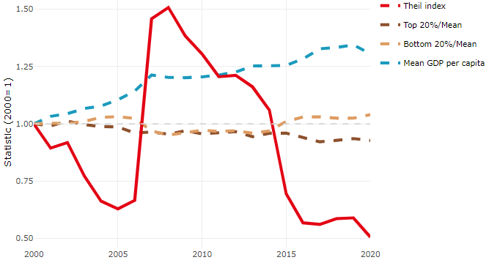

**Note**: Top/bottom calculated as population equivalent (top/bottom regions with at least 20% of the population). The interpretation of top/bottom 20% GDP per capita is that 20% of the population in the country holds 20% of the value. Top 20%/Mean calculated as mean GDP per capita in top 20% regions over mean TL3 GDP per capita in a given year. Bottom 20%/Mean calculated as mean TL3 GDP per capita in bottom 20% regions over mean TL3 GDP per capita in a given year. To improve data consistency, input series are aggregated when TL3 regions are part of the same FUA. To improve time series, TL3 missing values have been estimated based on the evolution at higher geographic level.

**Source**: OECD Regional Database (2022).

There is no data for the gap in GDP per capita between large metropolitan and non-large metropolitan regions for 2000 and 2020.

Meanwhile, in 2020, the gap in GDP per capita between metropolitan and non-metropolitan regions was 1.231. For reference, the same value for OECD was 1.325. This gap increased by 0.016 percentage points since 2000.

In turn, the gap in GDP per capita between regions near and far a Functional Urban Area (FUA) of more than 250 thousand inhabitants was 1.231 in 2020 and increased by 0.016 percentage points since 2000.

**Figure 2. GDP per capita gap by type of region compared to the OECD average**

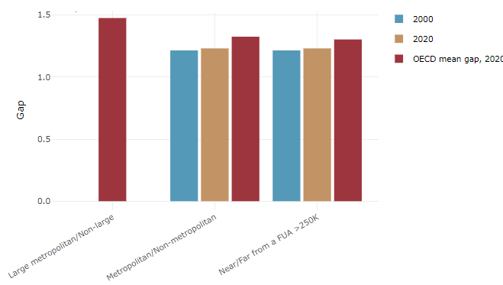

**Note**: Far from a FUA>250K includes regions near/with a small FUA and remote regions. OECD mean gap based on 1 586 TL3 regions in 27 countries with available data (no TL3 data for Australia, Canada, Chile, Colombia, Costa Rica, Iceland, Ireland, Israel, Mexico, Luxembourg and Switzerland).

**Source**: OECD Regional Database (2022).

In New Zealand, the gap between the upper and the lower half of regions in terms of labour productivity decreased between 2001 and 2019. Over this period labour productivity in the upper half of regions grew roughly by 12%, 10 percentage points less than in the lower half of regions.

**Figure 3. Evolution of labour productivity, TL3 OECD regions**

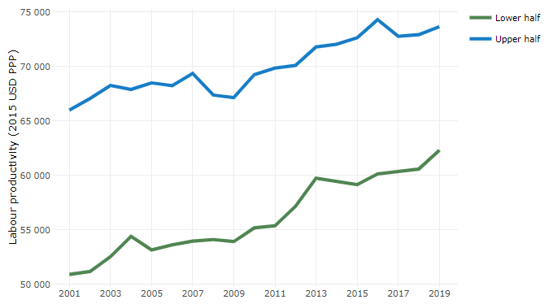

**Note**: A region is in the “upper half” if labour productivity was above the country median in the first year with available data and “lower half” if productivity was below the country median. Labour productivity in each group is equal to the sum of Gross Value Added, expressed in USD at constant prices and PPP (base year 2015) within the group, divided by the sum of total employment in regions within the group. Regions are small (TL3) regions, except for Australia, Canada, Chile, Colombia, Ireland, Mexico, Norway, Switzerland, Türkiye and the United States where they are large (TL2) regions due to data availability.

**Source**: OECD Regional Database (2022).

Regions where the economic activity shifts towards tradable activities, such as industry and tradable services, tend to grow faster in terms of labour productivity. In New Zealand, between 2001 and 2019, the share of workers in the industrial sector went down in all regions but more so in regions that used to be in the upper half of the labour productivity distribution. At the same time, the share of workers in the tradable services sector went up in all regions but more so in regions that were already in the upper half of the labour productivity distribution. Hence, the evolution of employment shares in the tradable services sector widened the labour productivity gap between regions while the opposite was true for the industrial sector.

**Figure 4. Share of workers in most productive (tradable) sectors, TL3 OECD regions**

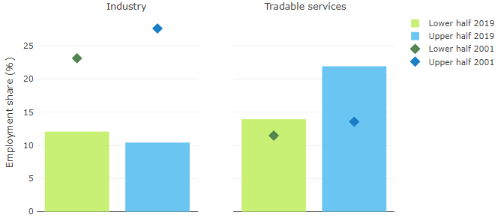

**Note**: A region is in the “upper half” if labour productivity was above the country median in the first year with available data and “lower half” if productivity was below the country median. The share of workers in a given sector for a group of regions is defined as the sum of employment in that sector within the group divided by the sum of total employment within the group. Regions are small (TL3) regions, except for Australia, Canada, Chile, Ireland, Mexico, Norway, Switzerland, Türkiye and the United States where they are large (TL2) regions due to data availability. Industry includes the following tradable goods sectors: Mining and quarrying (B), Manufacturing (C), Electricity, gas, steam and air conditioning supply (D) and Water supply; sewerage; waste management and remediation activities (E) NACE macro sectors. Tradable services include Information and communication (J), Financial and insurance activities (K), Real estate activities (L), Professional, scientific and technical activities (M), Administrative and support service activities (N).

**Source**: OECD Regional Database (2022).

## Recent policy developments

*Spatial Planning Act (SPA):* This bill is currently under development. Once implemented, it will ensure better and more strategic planning for how a region will grow, adapt and change over time, and how land, infrastructure and other resources will be used to promote the wellbeing of people, the environment and the economy. It will introduce, for the first time, a consistent, formal framework for spatial planning in New Zealand. It will provide certainty and enable change and adaptation in regions, with positive outcomes for the environment, community wellbeing and resilience. The SPA’s core function will be to mandate the use of spatial planning, which would require central government, local government and Māori to work together to develop long-term regional spatial strategies that set regional directions for at least the next 30 years. Work is underway to implement the SPA this year. The roll out will initially focus on three regions.

*Natural and Built Environment Act (NBA):* This bill is currently under development. It will be the main replacement for the Resource Management Act 1991. It aims to protect and restore the environment while better enabling development. The NBA will require any use of the environment to comply with environmental limits and targets. The environmental limits will be set at the current state of the natural environment at the time the NBA is passed to avoid further degradation. Associated targets will also be required to drive improvement in the natural environment. In areas that are already unacceptably degraded, minimum level targets will be required to improve the state of the environment, ensuring that existing degradation is not locked in.

*Climate Adaptation Act (CAA):* This bill is currently under development. It aims to address complex issues associated with managed retreat alongside funding climate adaptation. This is currently being worked on and is likely to be considered by the Government in 2023.

*The Future for Local Government Review:* The review identifies how New Zealand’s systems of local democracy and governance need to evolve over the next 30 years, in order to improve the wellbeing of New Zealand communities and the environment while actively embodying the Treaty partnership. This review is tasked with looking at what local government will do in the future, how it will be done and how it will be funded. The aim is to complete the review in June 2023.

*Industry Transformation Plans*: The New Zealand Government has committed to an industry policy which seeks to grow and transform sectors of the economy with significant potential, which would contribute to a highly productive, high-wage and low emissions economy. Industry Transformation Plans are created in partnership by business, workers, Māori and government, setting a long-term vision for transformative change and identifying near-term actions that will shift the sector toward realising it. These plans are currently under development. The eight industry transformation plans are:

1. Advanced Manufacturing,
2. Agritech,
3. Construction,
4. Digital Technologies,
5. Fisheries,
6. Food and Beverage,
7. Forestry and Wood Processing, and
8. Tourism